**Experiment No. 1**

**Aim:** Design a Login Form with username and password using LinearLayout and toast valid

Credentials

**CO1:** Design and develop user interfaces for mobile apps using basic building blocks, UI components and application structure using Emulator

**Procedure:**

activity_main

<?xml version="1.0" encoding="utf-8"?>

<LinearLayout

xmlns:android="http://schemas.android.com/apk/res/android"

android:layout_width="match_parent"

android:layout_height="match_parent"

android:orientation="vertical"

android:padding="16dp">

<TextView

android:id="@+id/textView"

android:layout_width="match_parent"

android:layout_height="wrap_content"

android:text="LOGIN FORM"

android:textAlignment="center" />

<TextView

android:id="@+id/textView1"

android:layout_width="wrap_content"

android:layout_height="wrap_content"

android:text="USERNAME" />

<EditText

android:id="@+id/usernameEditText"

android:layout_width="213dp"

android:layout_height="wrap_content"

android:layout_marginTop="8dp"

android:hint="Enter username" />

<TextView

android:id="@+id/textView2"

android:layout_width="wrap_content"

android:layout_height="wrap_content"

android:text="PASSWORD"

android:layout_marginTop="16dp"/>

<EditText

android:id="@+id/passwordEditText"

android:layout_width="215dp"

android:layout_height="wrap_content"

android:layout_marginTop="8dp"

android:hint="Enter password" />

<Button

android:id="@+id/loginButton"

android:layout_width="match_parent"

android:layout_height="wrap_content"

android:text="Login" />

</LinearLayout>

Main.activity

package com.example.firstapp;

import android.os.Bundle;

import android.view.View;

import android.widget.EditText;

import android.widget.Button;

import android.widget.Toast;

import androidx.appcompat.app.AppCompatActivity;

public class MainActivity extends AppCompatActivity {

private static final String VALID_USERNAME="user";

private static final String VALID_PASSWORD="password";

private EditText usernameEditText;

private EditText passwordEditText;

private Button loginButton;

@Override

protected void onCreate(Bundle savedInstanceState) {

super.onCreate(savedInstanceState);

setContentView(R.layout.activity_main);

usernameEditText=findViewById(R.id.usernameEditText);

passwordEditText=findViewById(R.id.passwordEditText);

loginButton=findViewById(R.id.loginButton);

loginButton.setOnClickListener(v -> {

String enteredUsername=usernameEditText.getText().toString();

String enteredPassword=passwordEditText.getText().toString();

if(isValidCredentials(enteredUsername,enteredPassword)) {

showToast("Login Successful");

}

else{

showToast("Invalid Credentials");

}

});}

private boolean isValidCredentials(String enteredUsername, String enteredPassword){

return VALID_USERNAME.equals(enteredUsername) && VALID_PASSWORD.equals(enteredPassword);

}

private void showToast(String message){

Toast.makeText(this,message,Toast.LENGTH_SHORT).show();

}

}

**Output:**

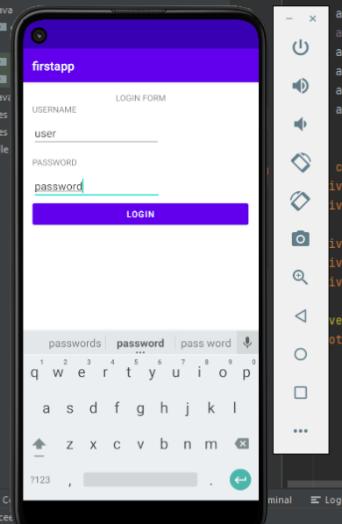

**Result :** The program was executed successfully and the output was obtained.

**Experiment No. 2**

**Aim:**Implementing basic arithmetic operations of a simple calculator

**CO1:** Design and develop user interfaces for mobile apps using basic building blocks, UI components and application structure using Emulator.

**CO2:** Write simple programs and develop small applications using the concepts of UI design, layouts and preferences

**Procedure:**

Activity_main

<?xml version="1.0" encoding="utf-8"?>

<LinearLayout

xmlns:android="http://schemas.android.com/apk/res/android"

xmlns:app="http://schemas.android.com/apk/res-auto"

xmlns:tools="http://schemas.android.com/tools"

android:layout_width="match_parent"

android:layout_height="match_parent"

android:orientation="vertical"

android:padding="30dp"

android:gravity="center_horizontal">

<!-- Text View -->

<TextView

android:id="@+id/TextView1"

android:layout_width="wrap_content"

android:layout_height="wrap_content"

android:text="Simple Calculator"

android:textColor="@color/black"

android:textSize="24sp"

android:layout_gravity="center"

android:layout_marginBottom="16dp"

android:textStyle="bold"/>

<!-- Edit Text-->

<EditText

android:id="@+id/EditText1"

android:layout_width="match_parent"

android:layout_height="wrap_content"

android:layout_margin="30dp"

android:layout_marginStart="50dp"

android:layout_marginTop="50dp"

android:layout_marginEnd="50dp"

android:layout_marginBottom="50dp" />

<GridLayout

android:layout_width="match_parent"

android:layout_height="wrap_content"

android:rowCount="4"

android:columnCount="4"

android:layout_gravity="center"

android:layout_marginTop="40dp">

<Button

android:id="@+id/button1"

android:layout_width="0dp"

android:layout_height="wrap_content"

style="?android:attr/buttonStyleSmall"

android:layout_columnWeight="1"

android:text="1"

android:textSize="18sp"

android:onClick="onDigitClick"/>

<Button

android:id="@+id/button2"

android:layout_width="0dp"

android:layout_height="wrap_content"

style="?android:attr/buttonStyleSmall"

android:layout_columnWeight="1"

android:text="2"

android:textSize="18sp"

android:onClick="onDigitClick"/>

<Button

android:id="@+id/button3"

android:layout_width="0dp"

android:layout_height="wrap_content"

style="?android:attr/buttonStyleSmall"

android:layout_columnWeight="1"

android:text="3"

android:textSize="18sp"

android:onClick="onDigitClick"/>

<Button

android:id="@+id/buttonDiv"

android:layout_width="0dp"

android:layout_height="wrap_content"

style="?android:attr/buttonStyleSmall"

android:layout_columnWeight="1"

android:text="/"

android:textSize="18sp"

android:onClick="onOperatorClick"/>

<Button

android:id="@+id/button4"

android:layout_width="0dp"

android:layout_height="wrap_content"

style="?android:attr/buttonStyleSmall"

android:layout_columnWeight="1"

android:text="4"

android:textSize="18sp"

android:onClick="onDigitClick"/>

<Button

android:id="@+id/button5"

android:layout_width="0dp"

android:layout_height="wrap_content"

style="?android:attr/buttonStyleSmall"

android:layout_columnWeight="1"

android:text="5"

android:textSize="18sp"

android:onClick="onDigitClick"/>

<Button

android:id="@+id/button6"

android:layout_width="0dp"

android:layout_height="wrap_content"

style="?android:attr/buttonStyleSmall"

android:layout_columnWeight="1"

android:text="6"

android:textSize="18sp"

android:onClick="onDigitClick"/>

<Button

android:id="@+id/buttonMul"

android:layout_width="0dp"

android:layout_height="wrap_content"

style="?android:attr/buttonStyleSmall"

android:layout_columnWeight="1"

android:text="*"

android:textSize="18sp"

android:onClick="onOperatorClick"/>

<Button

android:id="@+id/button7"

android:layout_width="0dp"

android:layout_height="wrap_content"

style="?android:attr/buttonStyleSmall"

android:layout_columnWeight="1"

android:text="7"

android:textSize="18sp"

android:onClick="onDigitClick"/>

<Button

android:id="@+id/button8"

android:layout_width="0dp"

android:layout_height="wrap_content"

style="?android:attr/buttonStyleSmall"

android:layout_columnWeight="1"

android:text="8"

android:textSize="18sp"

android:onClick="onDigitClick"/>

<Button

android:id="@+id/button9"

android:layout_width="0dp"

android:layout_height="wrap_content"

style="?android:attr/buttonStyleSmall"

android:layout_columnWeight="1"

android:text="9"

android:textSize="18sp"

android:onClick="onDigitClick"/>

<Button

android:id="@+id/buttonSub"

android:layout_width="0dp"

android:layout_height="wrap_content"

style="?android:attr/buttonStyleSmall"

android:layout_columnWeight="1"

android:text="-"

android:textSize="18sp"

android:onClick="onOperatorClick"/>

<Button

android:id="@+id/button0"

android:layout_width="0dp"

android:layout_height="wrap_content"

style="?android:attr/buttonStyleSmall"

android:layout_columnWeight="1"

android:text="0"

android:textSize="18sp"

android:onClick="onDigitClick"/>

<Button

android:id="@+id/buttonDot"

android:layout_width="0dp"

android:layout_height="wrap_content"

style="?android:attr/buttonStyleSmall"

android:layout_columnWeight="1"

android:text="C"

android:textSize="18sp"

android:onClick="onClearClick"/>

<Button

android:id="@+id/buttonEqual"

android:layout_width="0dp"

android:layout_height="wrap_content"

style="?android:attr/buttonStyleSmall"

android:layout_columnWeight="1"

android:text="="

android:textSize="18sp"

android:onClick="onEqualsClick"/>

<Button

android:id="@+id/buttonAdd"

android:layout_width="0dp"

android:layout_height="wrap_content"

style="?android:attr/buttonStyleSmall"

android:layout_columnWeight="1"

android:text="+"

android:textSize="18sp"

android:onClick="onOperatorClick"/>

</GridLayout>

</LinearLayout>

Main.activity

package com.example.calc;

import androidx.appcompat.app.AppCompatActivity;

import android.os.Bundle;

import android.view.View;

import android.widget.Button;

import android.widget.TextView;

public class MainActivity extends AppCompatActivity {

private TextView TextView1;

private Button button1;

private Button button2;

private Button button3;

private Button buttonDiv;

private Button button4;

private Button button5;

private Button button6;

private Button buttonMul;

private Button button7;

private Button button8;

private Button button9;

private Button buttonSub;

private Button button0;

private Button buttonDot;

private Button buttonEqual;

private Button buttonAdd;

private String currentInput = "";

private double operand1 = 0;

private String operator = "";

protected void onCreate(Bundle savedInstanceState) {

super.onCreate(savedInstanceState);

setContentView(R.layout.activity_main);

TextView1 = findViewById(R.id.TextView1);

}

public void onDigitClick(View view) {

Button button = (Button) view;

currentInput += button.getText().toString();

updateDisplay();

}

public void onOperatorClick(View view){

if (!currentInput.isEmpty()){

operand1 = Double.parseDouble(currentInput);

operator = ((Button) view).getText().toString();

currentInput = "";

}

}

public void onEqualsClick(View view){

if (!currentInput.isEmpty()){

double operand2 = Double.parseDouble(currentInput);

double result = performOperation(operand1,operand2,operator);

currentInput = String.valueOf((result));

updateDisplay();

}

}

public void onClearClick(View view){

currentInput = "";

operand1 = 0;

operator = "";

updateDisplay();

}

private double performOperation(double operand1, double operand2, String operator){

switch (operator){

case "+":

return operand1 + operand2;

case "-":

return operand1 - operand2;

case "*":

return operand1 * operand2;

case "/":

if (operand2 !=0) {

return operand1 / operand2;

} else {

return Double.NaN;

}

default:

return 0;

}

}

public void updateDisplay(){

TextView1.setText(currentInput);

}

}

**Output**

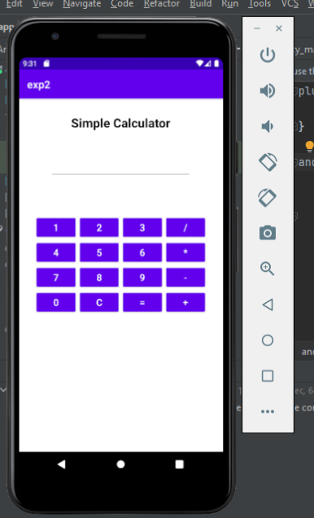 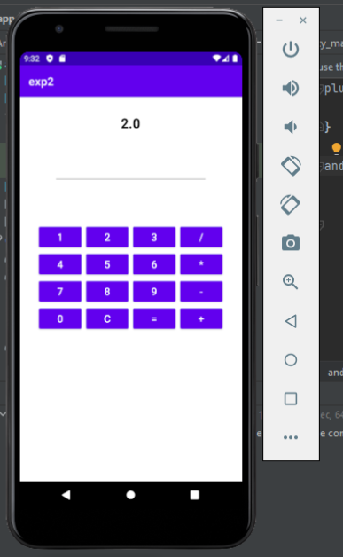

**Result :** The program was executed successfully and the output was obtained.

**Experiment No. 3**

**Aim:** Write a program that demonstrates Activity Lifecycle.

**CO1:** Design and develop user interfaces for mobile apps using basic building blocks, UI components and application structure using Emulator.

**Procedure:**

Activity_main

package com.example.cycle;

import androidx.appcompat.app.AppCompatActivity;

import android.os.Bundle;

import android.widget.Toast;

public class MainActivity extends AppCompatActivity {

@Override

protected void onCreate(Bundle savedInstanceState) {

super.onCreate(savedInstanceState);

setContentView(R.layout.activity_main);

showToast("Activity Created");

}

protected void onStart(){

super.onStart();

showToast("Activity Started");

}

protected void onResume(){

super.onResume();

showToast("Activity Resumed");

}

protected void onPause(){

super.onPause();

showToast("Activity Paused");

}

protected void onStop(){

super.onStop();

showToast("Activity Stopped");

}

protected void onRestart(){

super.onRestart();

showToast("Activity Restarted");

}

@Override

protected void onDestroy() {

super.onDestroy();

showToast("Activity Destroyed");

}

void showToast(String message){

Toast.makeText(this,message,Toast.LENGTH_LONG).show();

}

}

MainActivity.java

<?xml version="1.0" encoding="utf-8"?>

<androidx.constraintlayout.widget.ConstraintLayout xmlns:android="<http://schemas.android.com/apk/res/android>"

xmlns:app="<http://schemas.android.com/apk/res-auto>"

xmlns:tools="<http://schemas.android.com/tools>"

android:layout_width="match_parent"

android:layout_height="match_parent"

tools:context=".MainActivity">

<TextView

android:layout_width="match_parent"

android:layout_height="match_parent"

android:text="Activity Life Cycle"

android:textAlignment="center"

android:layout_marginTop="50dp"

android:textSize="30dp"/>

</androidx.constraintlayout.widget.ConstraintLayout>

output

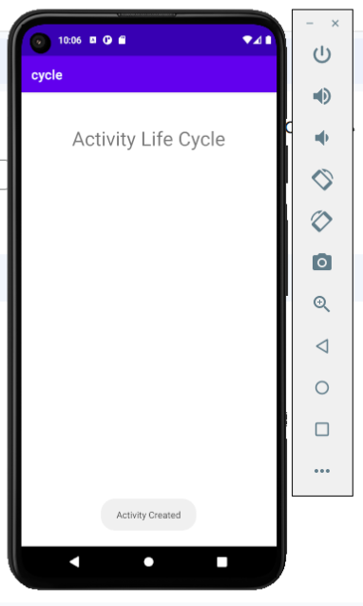 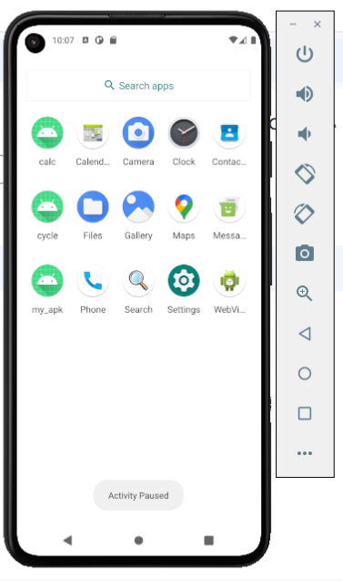

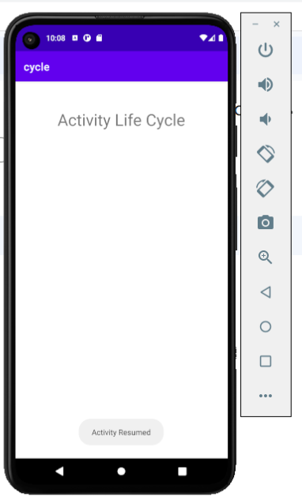 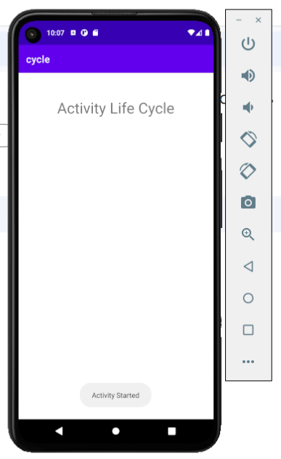

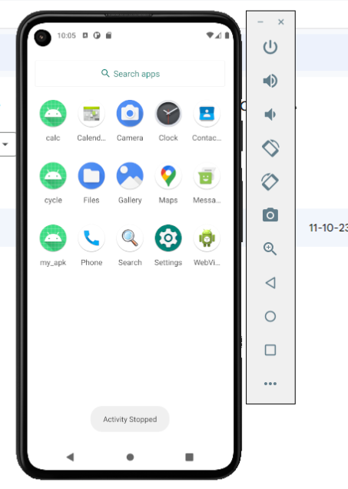

**Result :** The program was executed successfully and the output was obtained.

**Experiment No. 4**

**Aim:**Implement validations on various UI controls

**CO1:** Design and develop user interfaces for mobile apps using basic building blocks, UI components and application structure using Emulator.

**CO2:** Write simple programs and develop small applications using the concepts of UI design, layouts and preferences

**Procedure:**

Activity_main

<?xml version="1.0" encoding="utf-8"?>

<LinearLayout xmlns:android="http://schemas.android.com/apk/res/android"

xmlns:app="http://schemas.android.com/apk/res-auto"

xmlns:tools="http://schemas.android.com/tools"

android:layout_width="match_parent"

android:layout_height="match_parent"

android:orientation="vertical"

android:padding="16dp"

tools:context=".MainActivity">

<Button

android:id="@+id/constraintButton"

android:layout_width="match_parent"

android:layout_height="wrap_content"

android:text="ConstraintLayout" />

<Button

android:id="@+id/linearButton"

android:layout_width="match_parent"

android:layout_height="wrap_content"

android:text="LinearLayout" />

<Button

android:id="@+id/gridButton"

android:layout_width="match_parent"

android:layout_height="wrap_content"

android:text="GridLayout" />

<Button

android:id="@+id/relativeButton"

android:layout_width="match_parent"

android:layout_height="wrap_content"

android:text="RelativeLayout" />

<Button

android:id="@+id/frameButton"

android:layout_width="match_parent"

android:layout_height="wrap_content"

android:text="FrameLayout" />

<Button

android:id="@+id/tableButton"

android:layout_width="match_parent"

android:layout_height="wrap_content"

android:text="TableLayout" />

</LinearLayout>

MainActivity.java

package com.example.ui;

import android.os.Bundle;

import android.view.View;

import android.widget.Button;

import android.widget.Toast;

import androidx.appcompat.app.AppCompatActivity;

public class MainActivity extends AppCompatActivity {

@Override

protected void onCreate(Bundle savedInstanceState) {

super.onCreate(savedInstanceState);

setContentView(R.layout.activity_main);

Button constraintButton = findViewById(R.id.constraintButton);

Button linearButton = findViewById(R.id.linearButton);

Button gridButton = findViewById(R.id.gridButton);

Button relativeButton = findViewById(R.id.relativeButton);

Button frameButton = findViewById(R.id.frameButton);

Button tableButton = findViewById(R.id.tableButton);

View.OnClickListener buttonClickListener = new View.OnClickListener() {

@Override

public void onClick(View v) {

String layoutName = ((Button) v).getText().toString();

displayToken(layoutName);

}

};

constraintButton.setOnClickListener(buttonClickListener);

linearButton.setOnClickListener(buttonClickListener);

gridButton.setOnClickListener(buttonClickListener);

relativeButton.setOnClickListener(buttonClickListener);

frameButton.setOnClickListener(buttonClickListener);

tableButton.setOnClickListener(buttonClickListener);

}

private void displayToken(String layoutName) {

Toast.makeText(this, "Token from " + layoutName, Toast.LENGTH_SHORT).show();

}

}

**Output**

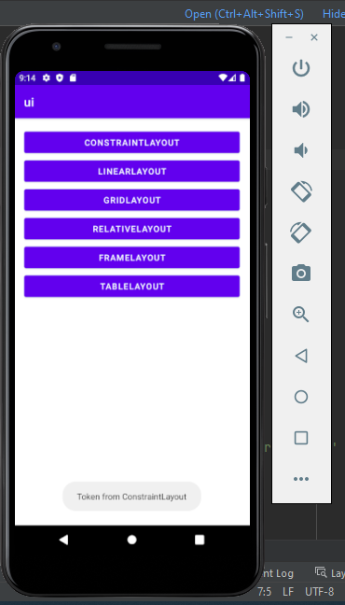 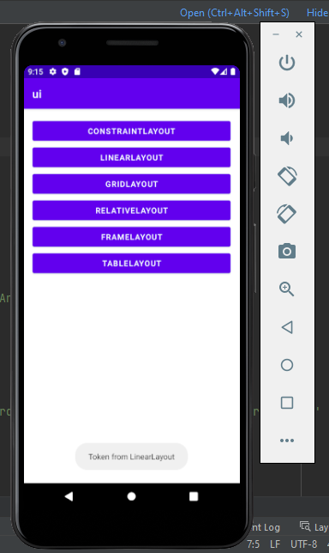

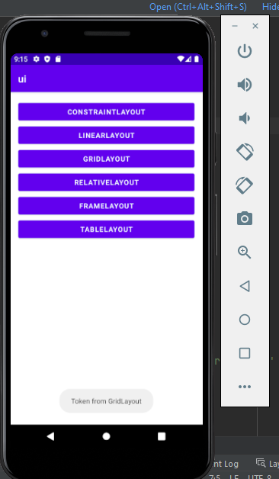 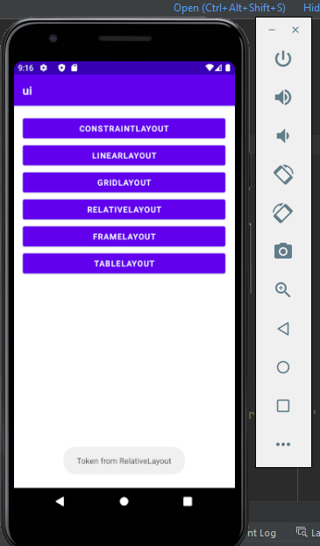

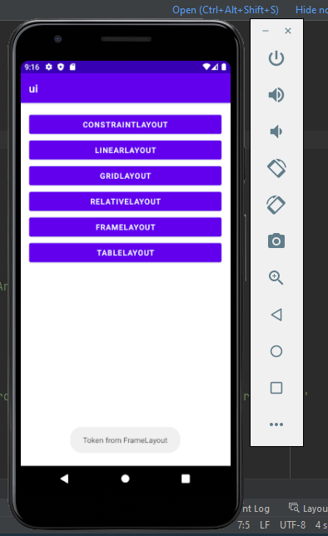 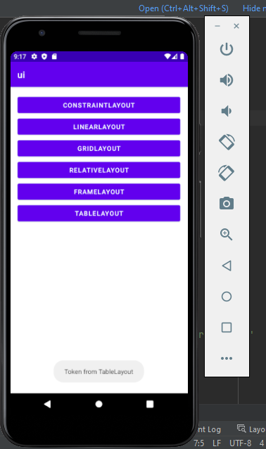

**Experiment No. 5**

**Aim:**Create a Facebook page using RelativeLayout; set properties using .xml file

**CO2:** Write simple programs and develop small applications using the concepts of UI design, layouts and preferences

**Procedure:**

Activity_main

<?xml version="1.0" encoding="utf-8"?>

<RelativeLayout xmlns:android="http://schemas.android.com/apk/res/android"

xmlns:app="http://schemas.android.com/apk/res-auto"

xmlns:tools="http://schemas.android.com/tools"

android:layout_width="fill_parent"

android:layout_height="fill_parent"

android:paddingLeft="16dp"

android:paddingRight="16dp" >

<ScrollView

android:layout_width="match_parent"

android:layout_height="match_parent">

<LinearLayout

android:layout_width="fill_parent"

android:layout_height="fill_parent"

android:orientation="vertical">

<ImageView

android:id="@+id/facebookView"

android:layout_width="200dp"

android:layout_height="80dp"

android:layout_gravity="center"

android:src="@drawable/facebook" />

<ImageView

android:id="@+id/imageView4"

android:layout_width="match_parent"

android:layout_height="281dp"

android:src="@drawable/post" />

<GridLayout

android:layout_width="match_parent"

android:layout_height="wrap_content"

android:layout_gravity="center"

android:layout_marginTop="40dp"

android:columnCount="4"

android:rowCount="4">

<!-- Like ImageView -->

<ImageView

android:id="@+id/likeImageView"

android:layout_width="110dp"

android:layout_height="83dp"

android:layout_gravity="center"

android:clickable="true"

android:onClick="onLikeClick"

android:src="@drawable/like" />

<!-- Comment ImageView -->

<ImageView

android:id="@+id/commentImageView"

android:layout_width="111dp"

android:layout_height="66dp"

android:layout_row="0"

android:layout_column="1"

android:layout_gravity="center"

android:clickable="true"

android:onClick="onCommentClick"

android:src="@drawable/comment" />

<ImageView

android:id="@+id/shareImageView"

android:layout_width="93dp"

android:layout_height="86dp"

android:layout_row="0"

android:layout_column="3"

android:layout_gravity="center"

android:clickable="true"

android:onClick="onShareClick"

android:src="@drawable/share" />

</GridLayout>

<LinearLayout

android:layout_width="match_parent"

android:layout_height="wrap_content"

android:orientation="vertical">

<ImageView

android:id="@+id/imageView7"

android:layout_width="match_parent"

android:layout_height="281dp"

android:src="@drawable/dog" />

<GridLayout

android:layout_width="match_parent"

android:layout_height="wrap_content"

android:layout_gravity="center"

android:layout_marginTop="40dp"

android:columnCount="4"

android:rowCount="4">

<!-- Like ImageView -->

<ImageView

android:id="@+id/likeImageView2"

android:layout_width="110dp"

android:layout_height="83dp"

android:layout_gravity="center"

android:clickable="true"

android:onClick="onLikeClick"

android:src="@drawable/like" />

<!-- (Your existing ImageView code) -->

<!-- Comment ImageView -->

<ImageView

android:id="@+id/commentImageView2"

android:layout_width="111dp"

android:layout_height="66dp"

android:layout_row="0"

android:layout_column="1"

android:layout_gravity="center"

android:clickable="true"

android:onClick="onCommentClick"

android:src="@drawable/comment" />

<ImageView

android:id="@+id/shareImageView2"

android:layout_width="93dp"

android:layout_height="86dp"

android:layout_row="0"

android:layout_column="3"

android:layout_gravity="center"

android:clickable="true"

android:onClick="onShareClick"

android:src="@drawable/share" />

<!-- (Your existing ImageView code) -->

</GridLayout>

</LinearLayout>

</LinearLayout>

</ScrollView>

</RelativeLayout>

MainActivity.java

package com.example.facebook;

import androidx.appcompat.app.AppCompatActivity;

import android.app.Activity;

import android.os.Bundle;

import android.view.View;

import android.widget.ImageView;

import android.widget.Toast;

public class MainActivity extends Activity {

@Override

protected void onCreate(Bundle savedInstanceState) {

super.onCreate(savedInstanceState);

setContentView(R.layout.activity_main);

// Find the ImageView elements by their IDs

ImageView facebookView = findViewById(R.id.facebookView );

ImageView likeImageView = findViewById(R.id.likeImageView);

ImageView commentImageView = findViewById(R.id.commentImageView);

ImageView shareImageView = findViewById(R.id.shareImageView);

// Set click listeners for the ImageViews

likeImageView.setOnClickListener(new View.OnClickListener() {

@Override

public void onClick(View v) {

showToast("You clicked the Like button");

}

});

commentImageView.setOnClickListener(new View.OnClickListener() {

@Override

public void onClick(View v) {

showToast("You clicked the Comment button");

}

});

shareImageView.setOnClickListener(new View.OnClickListener() {

@Override

public void onClick(View v) {

showToast("You clicked the Share button");

}

});

}

// Helper method to display a toast message

private void showToast(String message) {

Toast.makeText(this, message, Toast.LENGTH_SHORT).show();

}

}

**Output**

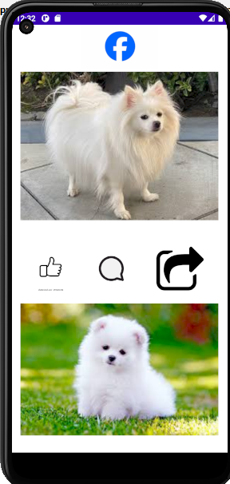 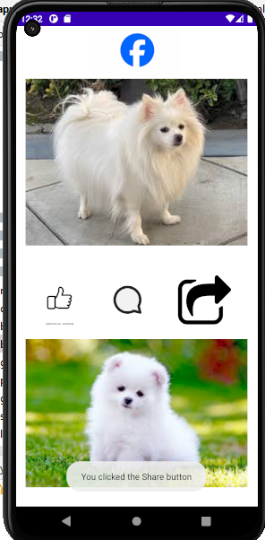

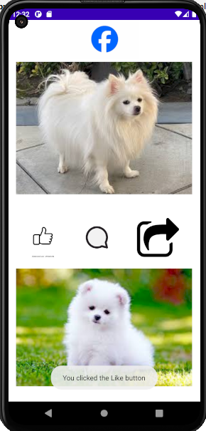 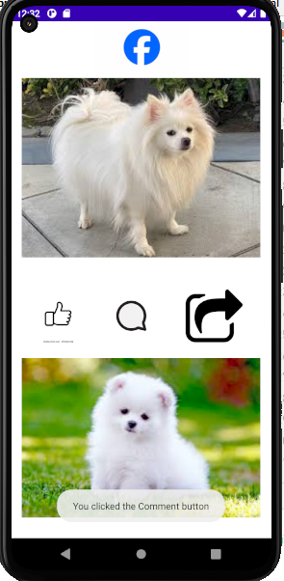

**Result :** The program was executed successfully and the output was obtained.

**Experiment No. 6**

**Aim:**Develop an application that toggles image using FrameLayout

**CO2:** Write simple programs and develop small applications using the concepts of UI design, layouts and preferences

**Procedure:**

Activity_main

<?xml version="1.0" encoding="utf-8"?>

<FrameLayout xmlns:android="http://schemas.android.com/apk/res/android"

xmlns:app="http://schemas.android.com/apk/res-auto"

xmlns:tools="http://schemas.android.com/tools"

android:layout_width="match_parent"

android:layout_height="match_parent"

android:background="#BDBABA"

tools:context=".MainActivity">

<ImageView

android:id="@+id/imageView1"

android:layout_width="427dp"

android:layout_height="wrap_content"

android:layout_gravity="left|top"

android:background="#CACAC8"

app:srcCompat="@drawable/s1" />

<ImageView

android:id="@+id/imageView2"

android:layout_width="396dp"

android:layout_height="wrap_content"

android:layout_gravity="left|top"

android:visibility="gone"

app:srcCompat="@drawable/f1" />

</FrameLayout>

MainActivity.java

javapackage com.example.frame_layout;

import androidx.appcompat.app.AppCompatActivity;

import android.os.Bundle;

import android.view.View;

import android.widget.ImageView;

public class MainActivity extends AppCompatActivity implements View.OnClickListener {

ImageView i1,i2;

@Override

protected void onCreate(Bundle savedInstanceState) {

super.onCreate(savedInstanceState);

setContentView(R.layout.activity_main);

i1=(ImageView) findViewById(R.id.imageView1);

i2=(ImageView) findViewById(R.id.imageView2);

i1.setOnClickListener(this);

i2.setOnClickListener(this);

}

@Override

public void onClick(View v) {

if(v.getId()==R.id.imageView1)

{

i1.setVisibility(v.GONE);

i2.setVisibility(v.VISIBLE);

}

else

{

i2.setVisibility(v.GONE);

i1.setVisibility(v.VISIBLE);

}

}

}

**Output**

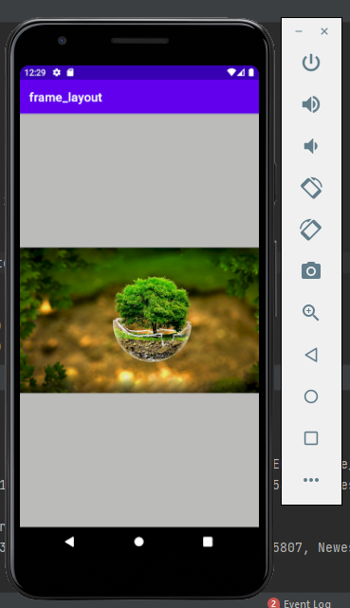 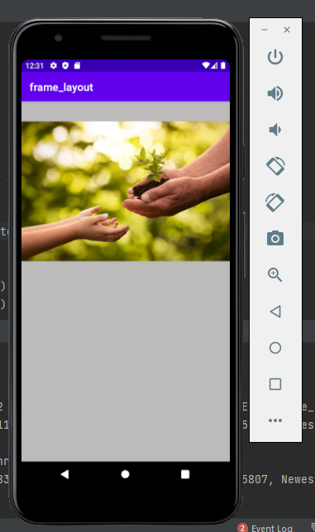

**Result :** The program was executed successfully and the output was obtained.

**Experiment No. 7**

**Aim:**Design a registration activity and store registration details in local memory of phone

using Intents and SharedPreferences.

**CO2:** Write simple programs and develop small applications using the concepts of UI design, layouts and preferences

**Procedure:**

Activity_main

<?xml version="1.0" encoding="utf-8"?>

<LinearLayout

xmlns:android="http://schemas.android.com/apk/res/android"

xmlns:app="http://schemas.android.com/apk/res-auto"

xmlns:tools="http://schemas.android.com/tools"

android:layout_width="match_parent"

android:layout_height="match_parent"

android:orientation="vertical"

android:padding="16dp"

android:gravity="center">

<EditText

android:id="@+id/usernameEditText"

android:layout_width="match_parent"

android:layout_height="wrap_content"

android:hint="Username"

android:inputType="text" />

<EditText

android:id="@+id/emailEditText"

android:layout_width="match_parent"

android:layout_height="wrap_content"

android:hint="Email"

android:inputType="textEmailAddress" />

<EditText

android:id="@+id/passwordEditText"

android:layout_width="match_parent"

android:layout_height="wrap_content"

android:hint="Password"

android:inputType="textPassword" />

<Button

android:id="@+id/registerButton"

android:layout_width="wrap_content"

android:layout_height="wrap_content"

android:layout_gravity="center"

android:text="Register" />

</LinearLayout>

MainActivity.java

package com.example.registration;

import android.content.Intent;

import android.content.SharedPreferences;

import android.os.Bundle;

import android.view.View;

import android.widget.Button;

import android.widget.EditText;

import android.widget.Toast;

import androidx.appcompat.app.AppCompatActivity;

public class MainActivity extends AppCompatActivity {

private EditText usernameEditText, emailEditText, passwordEditText;

private Button registerButton;

@Override

protected void onCreate(Bundle savedInstanceState) {

super.onCreate(savedInstanceState);

setContentView(R.layout.activity_main);

usernameEditText = findViewById(R.id.usernameEditText);

emailEditText = findViewById(R.id.emailEditText);

passwordEditText = findViewById(R.id.passwordEditText);

registerButton = findViewById(R.id.registerButton);

registerButton.setOnClickListener(new View.OnClickListener() {

@Override

public void onClick(View v) {

String username = usernameEditText.getText().toString();

String email = emailEditText.getText().toString();

String password = passwordEditText.getText().toString();

// Store registration details in SharedPreferences

SharedPreferences preferences = getSharedPreferences("MyPrefs", MODE_PRIVATE);

SharedPreferences.Editor editor = preferences.edit();

editor.putString("username", username);

editor.putString("email", email);

editor.putString("password", password);

editor.apply();

Toast.makeText(MainActivity.this, "Registration successful", Toast.LENGTH_SHORT).show();

// Start another activity, e.g., MainActivity, using an Intent

Intent intent = new Intent(MainActivity.this, MainActivity.class);

startActivity(intent);

}

});

}

}

**Output**

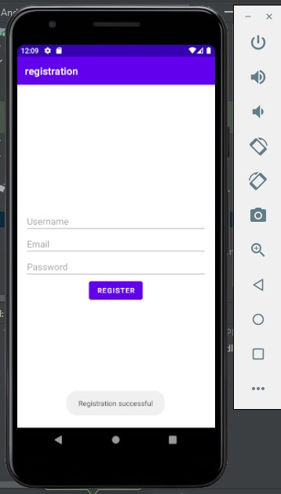

**Result :** The program was executed successfully and the output was obtained.

**Experiment No. 8**

**Aim:** Develop an application that uses ArrayAdapter with ListView.

**CO3:** Develop applications with multiple activities using intents, array adapter, exceptions and options menu.

**Procedure:**

Activity_main

<?xml version="1.0" encoding="utf-8"?>

<RelativeLayout xmlns:android="http://schemas.android.com/apk/res/android"

xmlns:app="http://schemas.android.com/apk/res-auto"

xmlns:tools="http://schemas.android.com/tools"

android:layout_width="match_parent"

android:layout_height="match_parent"

tools:context=".MainActivity" >

<ListView

android:id="@+id/dayLists"

android:layout_width="match_parent"

android:layout_height="match_parent" />

</RelativeLayout>

MainActivity.java

package com.example.days;

import androidx.appcompat.app.AppCompatActivity;

import android.os.Bundle;

import android.view.View;

import android.widget.AdapterView;

import android.widget.ArrayAdapter;

import android.widget.ListView;

import android.widget.TextView;

import android.widget.Toast;

public class MainActivity extends AppCompatActivity implements AdapterView.OnItemClickListener {

ListView l;

String [] days={"Sunday","Monday","Tuesday","Wednesday","Thursday","Friday","Saturday"};

@Override

protected void onCreate(Bundle savedInstanceState) {

super.onCreate(savedInstanceState);

setContentView(R.layout.activity_main);

l=findViewById(R.id.dayLists);

ArrayAdapter<String> adapter=new ArrayAdapter<String>(this, androidx.appcompat.R.layout.support_simple_spinner_dropdown_item,days);

l.setAdapter(adapter);

l.setOnItemClickListener(this);

}

@Override

public void onItemClick(AdapterView<?> adapterView, View view, int i, long l) {

TextView temp=(TextView) view;

Toast.makeText(this,"You clicked"+temp.getText()+"at"+i,Toast.LENGTH_LONG).show();

}

}

**Output**

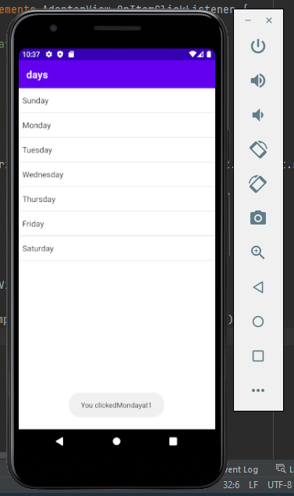 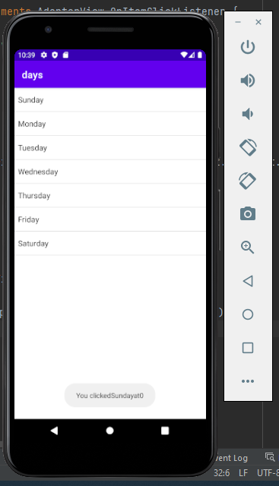

**Result :** The program was executed successfully and the output was obtained.

**Experiment No. 9**

**Aim:** Implement Intent to navigate between multiple activities

**CO3:** Develop applications with multiple activities using intents,array adapter, exceptions and options menu.

**Procedure:**

Activity_main.xml

<?xml version="1.0" encoding="utf-8"?>

<androidx.constraintlayout.widget.ConstraintLayout xmlns:android="http://schemas.android.com/apk/res/android"

xmlns:app="http://schemas.android.com/apk/res-auto"

xmlns:tools="http://schemas.android.com/tools"

android:layout_width="match_parent"

android:layout_height="match_parent"

tools:context=".MainActivity">

<TextView

android:layout_width="wrap_content"

android:layout_height="wrap_content"

android:text="activity1"

app:layout_constraintBottom_toBottomOf="parent"

app:layout_constraintEnd_toEndOf="parent"

app:layout_constraintStart_toStartOf="parent"

app:layout_constraintTop_toTopOf="parent" />

<Button

android:id="@+id/button"

android:layout_width="wrap_content"

android:layout_height="wrap_content"

android:text="Button"

android:onClick="switchActivity"

tools:layout_editor_absoluteX="158dp"

tools:layout_editor_absoluteY="390dp" />

</androidx.constraintlayout.widget.ConstraintLayout>

MainActivity.java

package com.example.activity1;

import androidx.appcompat.app.AppCompatActivity;

import android.content.Intent;

import android.os.Bundle;

import android.view.View;

public class MainActivity extends AppCompatActivity {

@Override

protected void onCreate(Bundle savedInstanceState) {

super.onCreate(savedInstanceState);

setContentView(R.layout.activity_main);

}

public void switchActivity(View view){

Intent intent=new Intent(this, activity2.class);

intent.putExtra("user","anagha");

startActivity(intent);

}

}

activity_2.xml

<?xml version="1.0" encoding="utf-8"?>

<androidx.constraintlayout.widget.ConstraintLayout xmlns:android="http://schemas.android.com/apk/res/android"

xmlns:app="http://schemas.android.com/apk/res-auto"

xmlns:tools="http://schemas.android.com/tools"

android:layout_width="match_parent"

android:layout_height="match_parent"

tools:context=".activity2">

<TextView

android:id="@+id/textView"

android:layout_width="wrap_content"

android:layout_height="wrap_content"

android:text="activity2"

tools:layout_editor_absoluteX="172dp"

tools:layout_editor_absoluteY="354dp" />

</androidx.constraintlayout.widget.ConstraintLayout>

activity2.java

package com.example.activity1;

import androidx.appcompat.app.AppCompatActivity;

import android.content.Intent;

import android.os.Bundle;

import android.widget.TextView;

public class activity2 extends AppCompatActivity {

TextView tv;

@Override

protected void onCreate(Bundle savedInstanceState) {

super.onCreate(savedInstanceState);

setContentView(R.layout.activity_2);

Intent intent=getIntent();

String user=intent.getStringExtra("user");

tv=findViewById(R.id.textView);

tv.setText(user);

}

}

**Output**

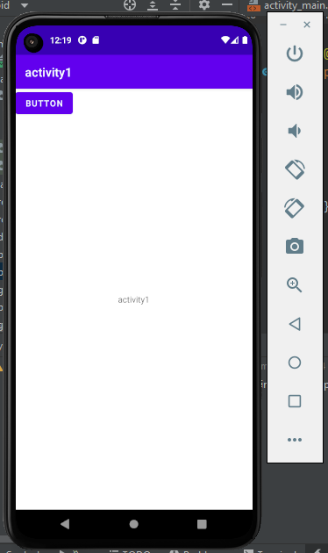 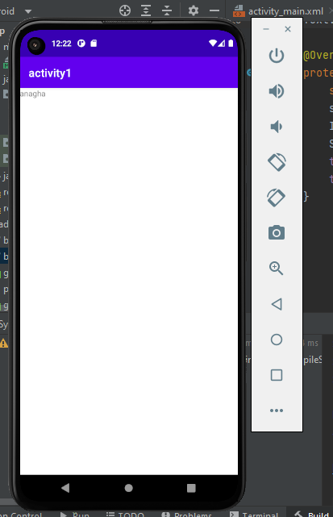

**Result :** The program was executed successfully and the output was obtained.

**Experiment No. 10**

**Aim:** Develop application that works with explicit intents

**CO3:** Develop applications with multiple activities using intents, array adapter, exceptions and options menu.

**Procedure:**

Activitymain.xml

<?xml version="1.0" encoding="utf-8"?>

<LinearLayout

xmlns:android="<http://schemas.android.com/apk/res/android>"

xmlns:app="<http://schemas.android.com/apk/res-auto>"

xmlns:tools="<http://schemas.android.com/tools>"

android:layout_width="match_parent"

android:layout_height="match_parent"

android:orientation="vertical"

android:padding="16dp"

android:gravity="center">

<EditText

android:id="@+id/e"

android:layout_width="match_parent"

android:layout_height="wrap_content"

android:inputType="text"

android:hint="enter the name" />

<EditText

android:id="@+id/e1"

android:layout_width="match_parent"

android:layout_height="wrap_content"

android:inputType="text"

android:hint="enter the age"/>

<Button

android:id="@+id/b1"

android:layout_width="wrap_content"

android:layout_height="wrap_content"

android:layout_gravity="center"

android:onClick="switchActivity"

android:text="Submit" />

</LinearLayout>

Activitymain.java

package com.example.in3;

import androidx.appcompat.app.AppCompatActivity;

import android.content.Intent;

import android.os.Bundle;

import android.view.View;

import android.widget.Button;

import android.widget.TextView;

public class MainActivity extends AppCompatActivity {

@Override

protected void onCreate(Bundle savedInstanceState) {

super.onCreate(savedInstanceState);

setContentView(R.layout.activity_main);

}

public void switchActivity(View view) {

TextView text = findViewById(R.id.e);

TextView text2 = findViewById(R.id.e1);

String data=text.getText().toString();

String data2=text2.getText().toString();

// Create an Intent to start MainActivity2

Intent intent = new Intent(this, MainActivity2.class);

// Put the data into the Intent

intent.putExtra("key",data );

intent.putExtra("key2", data2);

// Start MainActivity2 with the Intent

startActivity(intent);

}

}

Activitymain 2.xml

<?xml version="1.0" encoding="utf-8"?>

<LinearLayout

xmlns:android="<http://schemas.android.com/apk/res/android>"

xmlns:app="<http://schemas.android.com/apk/res-auto>"

xmlns:tools="<http://schemas.android.com/tools>"

android:layout_width="match_parent"

android:layout_height="match_parent"

android:orientation="vertical"

android:padding="16dp"

android:gravity="center">

<TextView

android:id="@+id/t1"

android:layout_width="wrap_content"

android:layout_height="wrap_content"

android:text="TextView"

tools:layout_editor_absoluteX="181dp"

tools:layout_editor_absoluteY="190dp" />

<TextView

android:id="@+id/t2"

android:layout_width="wrap_content"

android:layout_height="wrap_content"

android:text="TextView"

tools:layout_editor_absoluteX="175dp"

tools:layout_editor_absoluteY="237dp" />

</LinearLayout>

Activity main 2.java

package com.example.in3;

import androidx.appcompat.app.AppCompatActivity;

import android.content.Intent;

import android.os.Bundle;

import android.widget.TextView;

public class MainActivity2 extends AppCompatActivity {

@Override

protected void onCreate(Bundle savedInstanceState) {

super.onCreate(savedInstanceState);

setContentView(R.layout.activity_main2);

Intent intent = getIntent();

String receivedData = intent.getStringExtra("key");

String receivedData2 = intent.getStringExtra("key2");

// Display the received data in a TextView or do whatever you want with it

TextView data = findViewById(R.id.t1); // replace with the actual ID of your TextView

data.setText(receivedData);

TextView data2 = findViewById(R.id.t2); // replace with the actual ID of your TextView

data2.setText(receivedData2);

}

}

**Output**

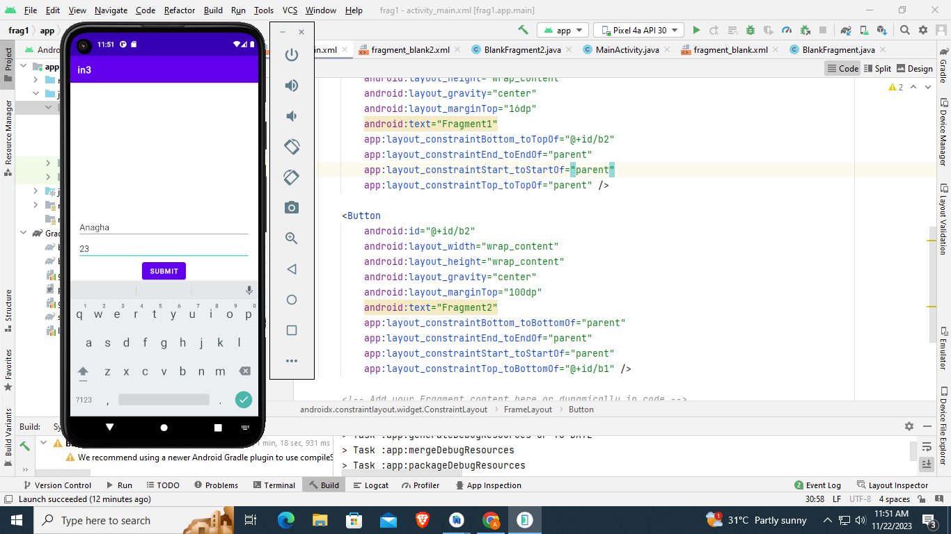 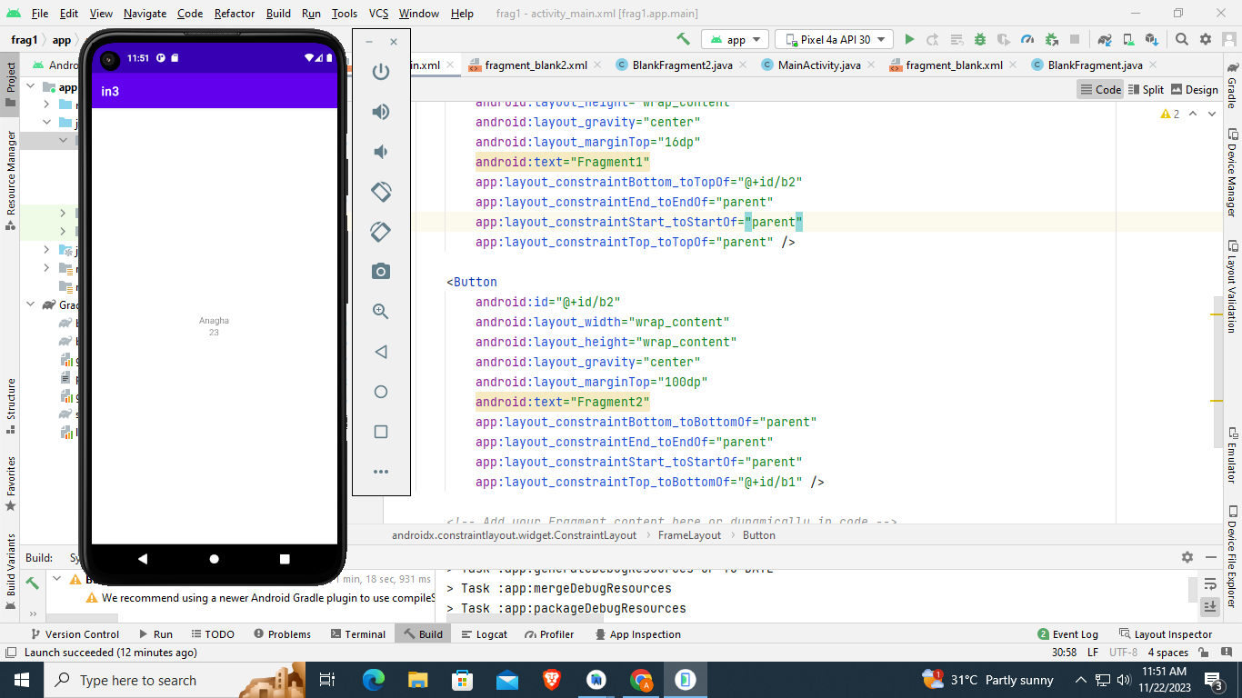

**Result :** The program was executed successfully and the output was obtained.

**Experiment No. 11**

**Aim:** Develop an application that implements Spinner component and perform event

handling

**CO4:** Implement activities with dialogs, spinner, fragments and navigation drawer by applying themes

**Procedure:**

Spin.xml

<?xml version="1.0" encoding="utf-8"?>

<RelativeLayout xmlns:android="http://schemas.android.com/apk/res/android"

xmlns:app="http://schemas.android.com/apk/res-auto"

xmlns:tools="http://schemas.android.com/tools"

android:layout_width="match_parent"

android:layout_height="match_parent"

tools:context=".MainActivity">

<TextView

android:id="@+id/textview1"

android:layout_width="wrap_content"

android:layout_height="wrap_content"

android:text="Hello World!"

android:layout_marginTop="50dp"

android:layout_marginLeft="150dp"/>

<Spinner

android:id="@+id/spinner2"

android:layout_height="50dp"

android:layout_width="200dp"

android:layout_marginTop="100dp"

android:layout_marginLeft="110dp"/>

</RelativeLayout>

Spin.java

package com.example.spin;

import androidx.appcompat.app.AppCompatActivity;

import android.os.Bundle;

import android.view.View;

import android.widget.AdapterView;

import android.widget.ArrayAdapter;

import android.widget.Spinner;

import android.widget.TextView;

public class MainActivity extends AppCompatActivity {

String []names = {"values1","values2","values3","value4","value5"};

String []text = {"values1 text","values2 text","values3 text","value4 text","value5 text"};

ArrayAdapter<String> adapter;

Spinner spinner;

TextView textView;

@Override

protected void onCreate(Bundle savedInstanceState) {

super.onCreate(savedInstanceState);

setContentView(R.layout.activity_main);

spinner = findViewById(R.id.spinner2);

textView = findViewById(R.id.textview1);

adapter = new ArrayAdapter<String>(getApplicationContext(), android.R.layout.simple_list_item_1,names);

spinner.setAdapter(adapter);

spinner.setOnItemSelectedListener(new AdapterView.OnItemSelectedListener() {

@Override

public void onItemSelected(AdapterView<?> adapterView, View view, int i, long l) {

switch (i)

{

case 0:

textView.setText(""+text[i]);

break;

case 1:

textView.setText(""+text[i]);

break;

case 2:

textView.setText(""+text[i]);

break;

case 3:

textView.setText(""+text[i]);

break;

case 4:

textView.setText(""+text[i]);

break;

}

}

@Override

public void onNothingSelected(AdapterView<?> adapterView) {

}

});

}

}

**Output**

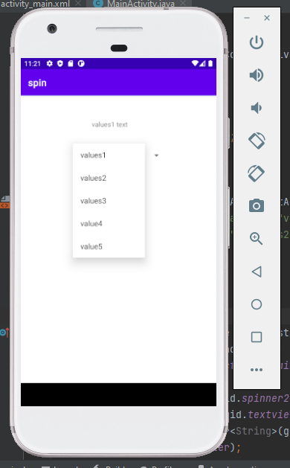 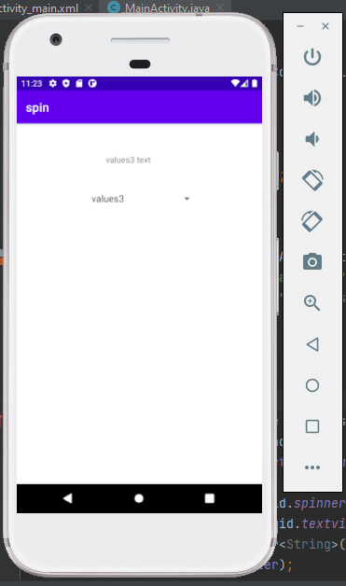

**Result :** The program was executed successfully and the output was obtained.

**Experiment No. 12**

**Aim:** Develop application using Fragments

**CO4:** Implement activities with dialogs, spinner, fragments and navigation drawer by applying themes

**Procedure:**

activity_main.xml

<?xml version="1.0" encoding="utf-8"?>

<RelativeLayout xmlns:android="http://schemas.android.com/apk/res/android"

xmlns:app="http://schemas.android.com/apk/res-auto"

xmlns:tools="http://schemas.android.com/tools"

android:layout_width="match_parent"

android:layout_height="match_parent"

tools:context=".MainActivity"

android:orientation="vertical">

<Button

android:id="@+id/button1"

android:layout_width="wrap_content"

android:layout_height="wrap_content"

android:layout_marginTop="150dp"

android:layout_marginLeft="150dp"

android:text="Fragmnet1" />

<Button

android:id="@+id/button2"

android:layout_width="wrap_content"

android:layout_height="wrap_content"

android:layout_marginTop="250dp"

android:layout_marginLeft="150dp"

android:text="Fragmernt2" />

<FrameLayout

android:id="@+id/frame"

android:layout_width="match_parent"

android:layout_height="match_parent">

</FrameLayout>

</RelativeLayout>

MainActivity.java

package com.example.exp11;

import androidx.appcompat.app.AppCompatActivity;

import android.os.Bundle;

import android.view.View;

import android.widget.Button;

public class MainActivity extends AppCompatActivity {

@Override

protected void onCreate(Bundle savedInstanceState) {

super.onCreate(savedInstanceState);

setContentView(R.layout.activity_main);

Button buttonfragment1 = findViewById(R.id.button1);

Button buttonfragment2 = findViewById(R.id.button2);

buttonfragment1.setOnClickListener(new View.OnClickListener() {

@Override

public void onClick(View view) {

getSupportFragmentManager().beginTransaction()

.replace(R.id.frame,new Fragment1())

.commit();

}

});

buttonfragment2.setOnClickListener(new View.OnClickListener() {

@Override

public void onClick(View view) {

getSupportFragmentManager().beginTransaction()

.replace(R.id.frame,new Fragment2())

.commit();

}

});

}

}

Fragment_1.xml

<?xml version="1.0" encoding="utf-8"?>

<FrameLayout xmlns:android="http://schemas.android.com/apk/res/android"

xmlns:tools="http://schemas.android.com/tools"

android:layout_width="match_parent"

android:layout_height="match_parent"

tools:context=".Fragment1">

<!-- TODO: Update blank fragment layout -->

<TextView

android:layout_width="match_parent"

android:layout_height="match_parent"

android:text="hello_blank_fragment1" />

</FrameLayout>

Fragment1.java

package com.example.exp11;

import android.os.Bundle;

import androidx.fragment.app.Fragment;

import android.view.LayoutInflater;

import android.view.View;

import android.view.ViewGroup;

/**

* A simple {@link Fragment} subclass.

* Use the {@link Fragment1#newInstance} factory method to

* create an instance of this fragment.

*/

public class Fragment1 extends Fragment {

// TODO: Rename parameter arguments, choose names that match

// the fragment initialization parameters, e.g. ARG_ITEM_NUMBER

private static final String ARG_PARAM1 = "param1";

private static final String ARG_PARAM2 = "param2";

// TODO: Rename and change types of parameters

private String mParam1;

private String mParam2;

public Fragment1() {

// Required empty public constructor

}

/**

* Use this factory method to create a new instance of

* this fragment using the provided parameters.

*

* @param param1 Parameter 1.

* @param param2 Parameter 2.

* @return A new instance of fragment Fragment1.

*/

// TODO: Rename and change types and number of parameters

public static Fragment1 newInstance(String param1, String param2) {

Fragment1 fragment = new Fragment1();

Bundle args = new Bundle();

args.putString(ARG_PARAM1, param1);

args.putString(ARG_PARAM2, param2);

fragment.setArguments(args);

return fragment;

}

@Override

public void onCreate(Bundle savedInstanceState) {

super.onCreate(savedInstanceState);

if (getArguments() != null) {

mParam1 = getArguments().getString(ARG_PARAM1);

mParam2 = getArguments().getString(ARG_PARAM2);

}

}

@Override

public View onCreateView(LayoutInflater inflater, ViewGroup container,

Bundle savedInstanceState) {

// Inflate the layout for this fragment

return inflater.inflate(R.layout.fragment_1, container, false);

}

}

Fragment_2.xml

<?xml version="1.0" encoding="utf-8"?>

<FrameLayout xmlns:android="http://schemas.android.com/apk/res/android"

xmlns:tools="http://schemas.android.com/tools"

android:layout_width="match_parent"

android:layout_height="match_parent"

tools:context=".Fragment2">

<!-- TODO: Update blank fragment layout -->

<TextView

android:layout_width="match_parent"

android:layout_height="match_parent"

android:text="hello_blank_fragment2" />

</FrameLayout>

Fragment2.java

package com.example.exp11;

import android.os.Bundle;

import androidx.fragment.app.Fragment;

import android.view.LayoutInflater;

import android.view.View;

import android.view.ViewGroup;

/**

* A simple {@link Fragment} subclass.

* Use the {@link Fragment2#newInstance} factory method to

* create an instance of this fragment.

*/

public class Fragment2 extends Fragment {

// TODO: Rename parameter arguments, choose names that match

// the fragment initialization parameters, e.g. ARG_ITEM_NUMBER

private static final String ARG_PARAM1 = "param1";

private static final String ARG_PARAM2 = "param2";

// TODO: Rename and change types of parameters

private String mParam1;

private String mParam2;

public Fragment2() {

// Required empty public constructor

}

/**

* Use this factory method to create a new instance of

* this fragment using the provided parameters.

*

* @param param1 Parameter 1.

* @param param2 Parameter 2.

* @return A new instance of fragment Fragment2.

*/

// TODO: Rename and change types and number of parameters

public static Fragment2 newInstance(String param1, String param2) {

Fragment2 fragment = new Fragment2();

Bundle args = new Bundle();

args.putString(ARG_PARAM1, param1);

args.putString(ARG_PARAM2, param2);

fragment.setArguments(args);

return fragment;

}

@Override

public void onCreate(Bundle savedInstanceState) {

super.onCreate(savedInstanceState);

if (getArguments() != null) {

mParam1 = getArguments().getString(ARG_PARAM1);

mParam2 = getArguments().getString(ARG_PARAM2);

}

}

@Override

public View onCreateView(LayoutInflater inflater, ViewGroup container,

Bundle savedInstanceState) {

// Inflate the layout for this fragment

return inflater.inflate(R.layout.fragment_2, container, false);

}

}

**Output**

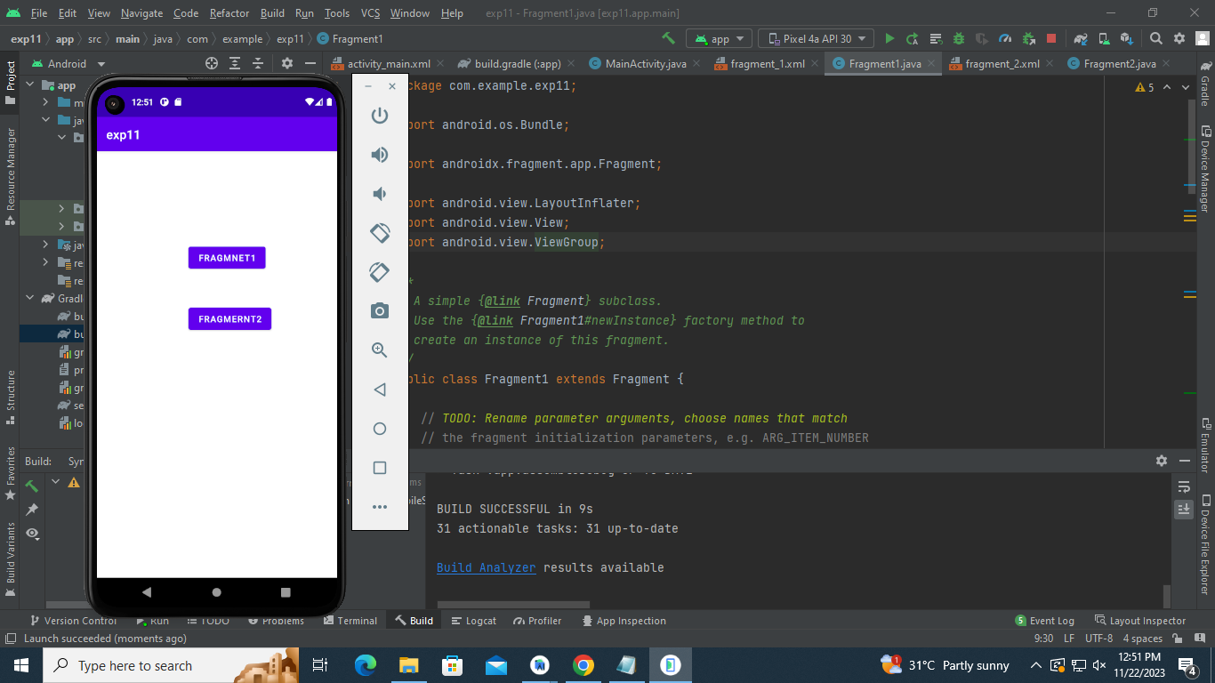 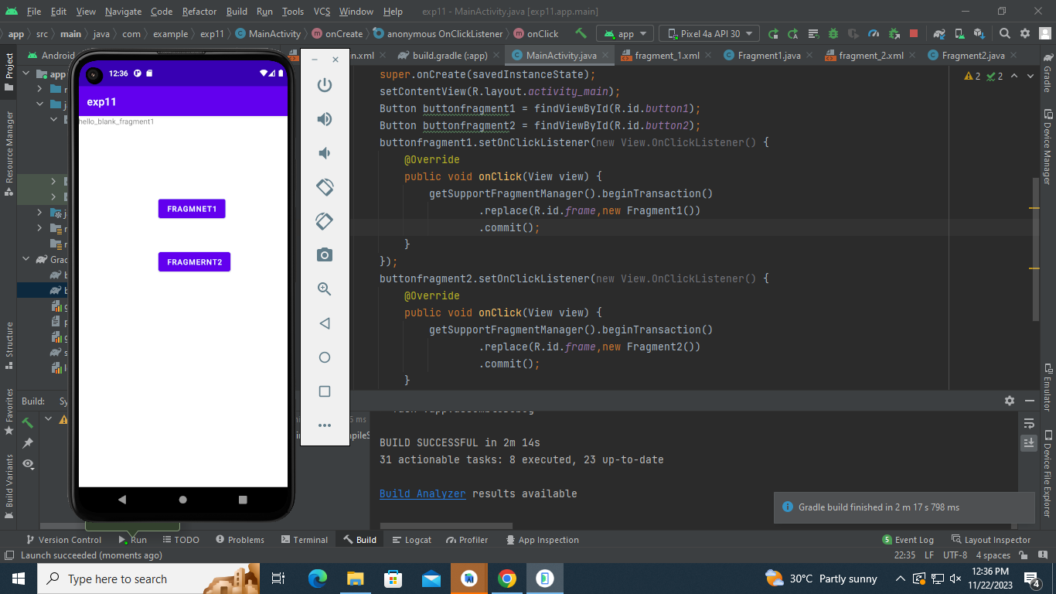

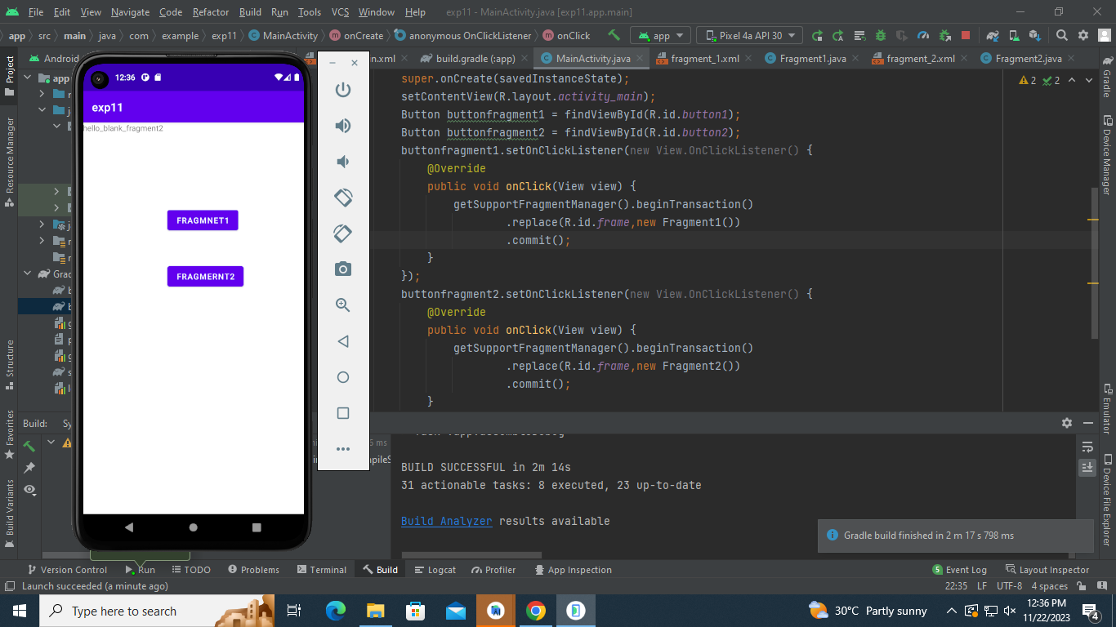

**Result :** The program was executed successfully and the output was obtained.

**Experiment No. 13**

**Aim:** Implement Adapters and perform exception handling

**CO3:** Develop applications with multiple activities using intents, array adapter, exceptions and options menu.

**Procedure:**

Activity_main.xml

<?xml version="1.0" encoding="utf-8"?>

<RelativeLayout

xmlns:android="http://schemas.android.com/apk/res/android"

xmlns:app="http://schemas.android.com/apk/res-auto"

xmlns:tools="http://schemas.android.com/tools"

android:layout_width="match_parent"

android:layout_height="match_parent"

tools:context=".MainActivity">

<ListView

android:id="@+id/list"

android:layout_width="match_parent"

android:layout_height="match_parent"/>

</RelativeLayout>

MainActivity.java

package com.example.atry;

import androidx.appcompat.app.AppCompatActivity;

import android.os.Bundle;

import android.widget.Toast;

import java.util.ArrayList;

import java.util.List;

public class MainActivity extends AppCompatActivity {

List<String> list=new ArrayList();

@Override

protected void onCreate(Bundle savedInstanceState) {

super.onCreate(savedInstanceState);

setContentView(R.layout.activity_main);

list.add("ITEM 1");

list.add("ITEM 2");

list.add("ITEM 3");

list.add("ITEM 4");

for(int i=0;i<5;i++){

try{

list.get(i);

}

catch(Exception e){

Toast.makeText(this,"Exception caught",Toast.LENGTH_LONG).show();

}

}

}

}

**Output**

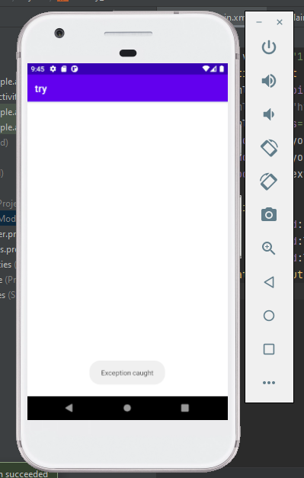

**Result :** The program was executed successfully and the output was obtained.

**Experiment No. 14**

**Aim:** Apply themes via code and manifest file

**CO4:** Implement activities with dialogs, spinner, fragments and navigation drawer by applying themes

**Procedure:**

Activity_main.xml

<?xml version="1.0" encoding="utf-8"?>

<androidx.constraintlayout.widget.ConstraintLayout xmlns:android="http://schemas.android.com/apk/res/android"

xmlns:app="http://schemas.android.com/apk/res-auto"

xmlns:tools="http://schemas.android.com/tools"

android:layout_width="match_parent"

android:layout_height="match_parent"

tools:context=".MainActivity">

<EditText

android:id="@+id/EditText"

android:layout_width="match_parent"

android:layout_height="wrap_content"

android:layout_margin="30dp"

android:text="Name"

tools:layout_editor_absoluteX="30dp"

tools:layout_editor_absoluteY="286dp" />

</androidx.constraintlayout.widget.ConstraintLayout>

MainActivity.java

package com.example.color;

import androidx.appcompat.app.AppCompatActivity;

import android.os.Bundle;

public class MainActivity extends AppCompatActivity {

@Override

protected void onCreate(Bundle savedInstanceState) {

super.onCreate(savedInstanceState);

setContentView(R.layout.activity_main);

}

}

Colors.xml

<?xml version="1.0" encoding="utf-8"?>

<resources>

<color name="purple_200">#FFBB86FC</color>

<color name="purple_500">#FF6200EE</color>

<color name="purple_700">#FF3700B3</color>

<color name="teal_200">#FF03DAC5</color>

<color name="teal_700">#FF018786</color>

<color name="black">#FF000000</color>

<color name="white">#FFFFFFFF</color>

<color name="colorPrimary">#ffa4a2</color>

<color name="color_primary_dark">#8c0032</color>

<color name="color_accent">#aa00c7</color>

<color name="color_text_color_primary">#66ffa6</color>

</resources>

themes.xml

<resources xmlns:tools="http://schemas.android.com/tools">

<!-- Base application theme. -->

<style name="Theme.Color" parent="Theme.MaterialComponents.DayNight.DarkActionBar">

<item name="colorPrimary">@color/colorPrimary</item>

<item name="colorPrimaryContainer">@color/color_primary_dark</item>

<item name="colorAccent">@color/color_accent</item>

<item name="android:textColorPrimary">@color/color_text_color_primary</item>

<item name="android:textSize">40dp</item>

</style>

</resources>

new_style.xml

<?xml version="1.0" encoding="utf-8"?>

<resources>

<style name="Theme.new_style" parent="Theme.MaterialComponents.DayNight.DarkActionBar">

<item name="colorPrimary">@color/colorPrimary</item>

<item name="colorPrimaryContainer">@color/color_primary_dark</item>

<item name="colorAccent">@color/color_accent</item>

<item name="android:textColorPrimary">@color/color_text_color_primary</item>

<item name="android:textSize">40dp</item>

</style>

</resources>

AndroidManifest.xml

<?xml version="1.0" encoding="utf-8"?>

<manifest xmlns:android="http://schemas.android.com/apk/res/android"

xmlns:tools="http://schemas.android.com/tools"

package="com.example.color">

<application

android:allowBackup="true"

android:dataExtractionRules="@xml/data_extraction_rules"

android:fullBackupContent="@xml/backup_rules"

android:icon="@mipmap/ic_launcher"

android:label="@string/app_name"

android:roundIcon="@mipmap/ic_launcher_round"

android:supportsRtl="true"

android:theme="@style/Theme.new_style"

tools:targetApi="31">

<activity

android:name=".MainActivity"

android:exported="true">

<intent-filter>

<action android:name="android.intent.action.MAIN" />

<category android:name="android.intent.category.LAUNCHER" />

</intent-filter>

</activity>

</application>

</manifest>

**Output**

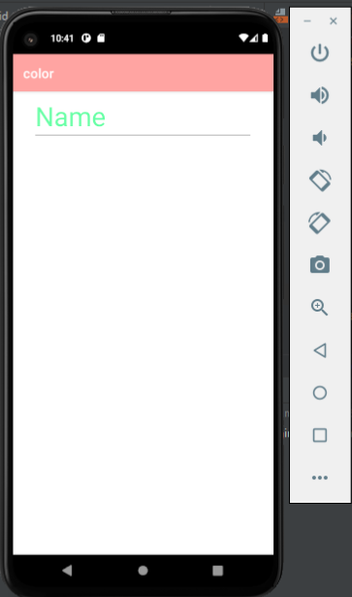

**Result :** The program was executed successfully and the output was obtained.

**Experiment No. 15**

**Aim:** 1. Create database using SQLite and perform INSERT and SELECT

2. Perform UPDATE and DELETE on SQLite database

**CO5:** Develop mobile applications using SQLite

**Procedure:**

Activity_main.xml

<?xml version="1.0" encoding="utf-8"?>

<RelativeLayout xmlns:android="http://schemas.android.com/apk/res/android"

xmlns:app="http://schemas.android.com/apk/res-auto"

xmlns:tools="http://schemas.android.com/tools"

android:layout_width="match_parent"

android:layout_height="match_parent"

tools:context=".MainActivity">

<TextView

android:id="@+id/tv1"

android:layout_centerHorizontal="true"

android:layout_width="wrap_content"

android:layout_height="wrap_content"

android:textColor="@color/black"

android:text="Student Details"

android:textSize="15sp" />

<EditText

android:id="@+id/et1"

android:layout_width="wrap_content"

android:layout_height="wrap_content"

android:hint="Enter rollno"

android:layout_centerHorizontal="true"

android:layout_margin="18dp"

android:layout_below="@+id/tv1"/>

<EditText

android:id="@+id/et2"

android:layout_width="wrap_content"

android:layout_height="wrap_content"

android:hint="Enter name"

android:layout_centerHorizontal="true"

android:layout_margin="18dp"

android:layout_below="@+id/et1"/>

<EditText

android:id="@+id/et3"

android:layout_width="wrap_content"

android:layout_height="wrap_content"

android:layout_below="@+id/et2"

android:layout_centerHorizontal="true"

android:layout_marginStart="18dp"

android:layout_marginTop="22dp"

android:layout_marginEnd="18dp"

android:layout_marginBottom="18dp"

android:hint="Enter department" />

<Button

android:id="@+id/bt1"

android:layout_width="wrap_content"

android:layout_height="wrap_content"

android:text="Insert"

android:onClick="onInsert"

android:layout_centerHorizontal="true"

android:layout_margin="10dp"

android:layout_below="@+id/et3"/>

<Button

android:id="@+id/bt2"

android:layout_width="wrap_content"

android:layout_height="wrap_content"

android:text="Update"

android:onClick="onUpdate"

android:layout_centerHorizontal="true"

android:layout_margin="10dp"

android:layout_below="@+id/bt1"/>

<Button

android:id="@+id/bt3"

android:layout_width="wrap_content"

android:layout_height="wrap_content"

android:text="Read"

android:onClick="onRead"

android:layout_centerHorizontal="true"

android:layout_margin="10dp"

android:layout_below="@+id/bt2"/>

<Button

android:id="@+id/bt4"

android:layout_width="wrap_content"

android:layout_height="wrap_content"

android:text="Delete"

android:onClick="onDelete"

android:layout_centerHorizontal="true"

android:layout_margin="10dp"

android:layout_below="@+id/bt3"/>

</RelativeLayout>

MainActivity.java

package com.example.sqlite;

import androidx.appcompat.app.AppCompatActivity;

import android.content.ContentValues;

import android.database.Cursor;

import android.database.sqlite.SQLiteDatabase;

import android.os.Bundle;

import android.view.View;

import android.widget.Button;

import android.widget.EditText;

import android.widget.TextView;

import android.widget.Toast;

public class MainActivity extends AppCompatActivity {

TextView tv1;

EditText et1,et2,et3;

Button bt1,bt2,bt3,bt4;

String rno;

String name;

String dept;

SQLiteDatabase db;

@Override

protected void onCreate(Bundle savedInstanceState) {

super.onCreate(savedInstanceState);

setContentView(R.layout.activity_main);

tv1 = findViewById(R.id.tv1);

et1 = findViewById(R.id.et1);

et2 = findViewById(R.id.et2);

et3 = findViewById(R.id.et3);

bt1 = findViewById(R.id.bt1);

bt2 = findViewById(R.id.bt2);

bt3 = findViewById(R.id.bt3);

bt4 = findViewById(R.id.bt4);

DbHelper dbHelper = new DbHelper(this);

db = dbHelper.getWritableDatabase();

db = dbHelper.getReadableDatabase();

}

public void onInsert(View view) {

rno = et1.getText().toString();

name = et2.getText().toString();

dept = et3.getText().toString();

if (rno.equals("") || name.equals("") || dept.equals("")) {

Toast.makeText(this,"please enter values",Toast.LENGTH_LONG).show();

}

else {

ContentValues values = new ContentValues();

values.put("rollno",rno);

values.put("name",name);

values.put("dept",dept);

db.insert("student",null,values);

Toast.makeText(this,"Inserted",Toast.LENGTH_LONG).show();

}

}

public void onUpdate(View view) {

rno = et1.getText().toString();

name = et2.getText().toString();

dept = et3.getText().toString();

if (rno.equals("") || name.equals("") || dept.equals("")) {

Toast.makeText(this,"please enter values",Toast.LENGTH_LONG).show();

}

else {

ContentValues values = new ContentValues();

values.put("rollno",rno);

values.put("name",name);

values.put("dept",dept);

db.update("student",values,"rollno="+rno,null);

Toast.makeText(this,"Updated",Toast.LENGTH_LONG).show();

}

}

public void onRead(View view) {

StringBuffer buffer = new StringBuffer();

Cursor c=db.rawQuery("select * from student",null);

while (c.moveToNext())

{

buffer.append("\n"+c.getString(0));

buffer.append("\n"+c.getString(1));

buffer.append("\n"+c.getString(2));

}

Toast.makeText(this,buffer.toString(), Toast.LENGTH_SHORT).show();

}

public void onDelete(View view) {

rno = et1.getText().toString();

name = et2.getText().toString();

dept = et3.getText().toString();

if (rno.equals(""))

{

Toast.makeText(this, "Pls enter value", Toast.LENGTH_LONG).show();

}

else

{

db.delete("student","rollno="+rno,null);

Toast.makeText(this, "Deleted", Toast.LENGTH_LONG).show();

}

}

}

DBHelper.java

package com.example.sqlite;

import android.content.Context;

import android.database.sqlite.SQLiteDatabase;

import android.database.sqlite.SQLiteOpenHelper;

import androidx.annotation.Nullable;

class DbHelper extends SQLiteOpenHelper {

public DbHelper(@Nullable Context context) {

super(context, "student.db", null, 1);

}

@Override

public void onCreate(SQLiteDatabase sqLiteDatabase) {

sqLiteDatabase.execSQL("create table student(rollno int,name varchar(20),dept varchar(5))");

}

@Override

public void onUpgrade(SQLiteDatabase sqLiteDatabase, int i, int i1) {

sqLiteDatabase.execSQL("drop table if exists student");

onCreate(sqLiteDatabase);

}

}

**Output**

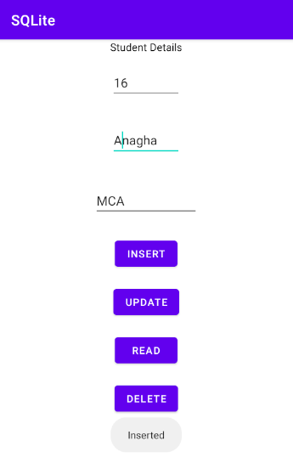 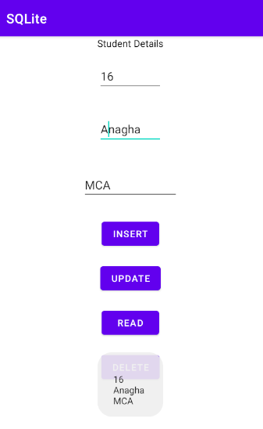

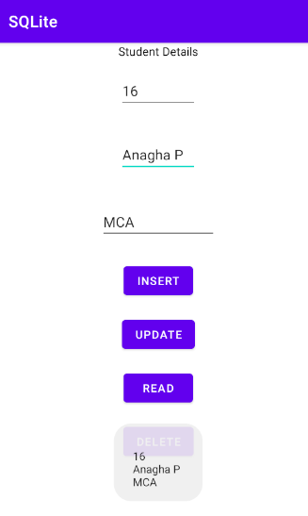 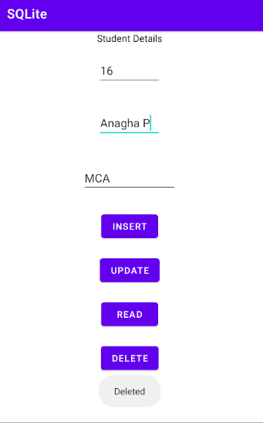

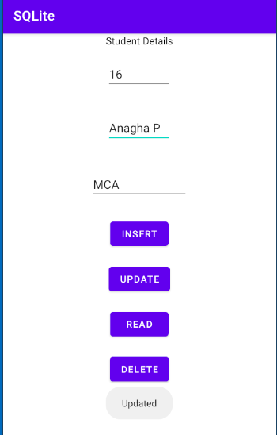

**Result :** The program was executed successfully and the output was obtained.

**Experiment No. 16**

**Aim:** Implement Options Menu to navigate to activities

**CO3:** Develop applications with multiple activities using intents, array adapter, exceptions

and options menu.

**Procedure:**

activity_main.xml

<?xml version="1.0" encoding="utf-8"?>

<androidx.constraintlayout.widget.ConstraintLayout xmlns:android="http://schemas.android.com/apk/res/android"

xmlns:app="http://schemas.android.com/apk/res-auto"

xmlns:tools="http://schemas.android.com/tools"

android:layout_width="match_parent"

android:layout_height="match_parent"

tools:context=".MainActivity">

<TextView

android:layout_width="wrap_content"

android:layout_height="wrap_content"

android:text="Hello World!"

app:layout_constraintBottom_toBottomOf="parent"

app:layout_constraintEnd_toEndOf="parent"

app:layout_constraintStart_toStartOf="parent"

app:layout_constraintTop_toTopOf="parent" />

</androidx.constraintlayout.widget.ConstraintLayout>

//menu_main.xml

<?xml version="1.0" encoding="utf-8"?>

<menu xmlns:android="http://schemas.android.com/apk/res/android">

<item

android:id="@+id/settings"

android:title="settings"/>

<item

android:id="@+id/about"

android:title="about"/>

<item

android:id="@+id/msgs"

android:title="starred messages"/>

</menu>

activity_settingspage.xml

<?xml version="1.0" encoding="utf-8"?>

<androidx.constraintlayout.widget.ConstraintLayout xmlns:android="http://schemas.android.com/apk/res/android"

xmlns:app="http://schemas.android.com/apk/res-auto"

xmlns:tools="http://schemas.android.com/tools"

android:layout_width="match_parent"

android:layout_height="match_parent"

tools:context=".settingspage">

<TextView

android:layout_width="wrap_content"

android:layout_height="wrap_content"

android:text="Hello!"

app:layout_constraintBottom_toBottomOf="parent"

app:layout_constraintEnd_toEndOf="parent"

app:layout_constraintStart_toStartOf="parent"

app:layout_constraintTop_toTopOf="parent" />

</androidx.constraintlayout.widget.ConstraintLayout>

settingspage.java

package com.example.option;

import androidx.appcompat.app.AppCompatActivity;

import android.os.Bundle;

public class settingspage extends AppCompatActivity {

@Override

protected void onCreate(Bundle savedInstanceState) {

super.onCreate(savedInstanceState);

setContentView(R.layout.activity_settingspage);

}

}

MainActivity.java

package com.example.option;

import androidx.annotation.NonNull;

import androidx.appcompat.app.AppCompatActivity;

import android.content.Intent;

import android.os.Bundle;

import android.view.Menu;

import android.view.MenuInflater;

import android.view.MenuItem;

import android.widget.Toast;

public class MainActivity extends AppCompatActivity {

@Override

protected void onCreate(Bundle savedInstanceState) {

super.onCreate(savedInstanceState);

setContentView(R.layout.activity_main);

}

@Override

public boolean onCreateOptionsMenu(Menu menu) {

MenuInflater inflater = getMenuInflater();

inflater.inflate(R.menu.menu_main,menu);

return super.onCreateOptionsMenu(menu);

}

@Override

public boolean onOptionsItemSelected(@NonNull MenuItem item) {

switch(item.getItemId())

{

case R.id.settings:

Intent intent = new Intent(MainActivity.this,settingspage.class);

startActivity(intent);

break;

case R.id.about:

Toast.makeText(this,"you clicked about",Toast.LENGTH_LONG).show();

break;

case R.id.msgs:

Toast.makeText(this,"you clicked starred messages",Toast.LENGTH_LONG).show();

break;

}

return super.onOptionsItemSelected(item);

}

}

**Output**

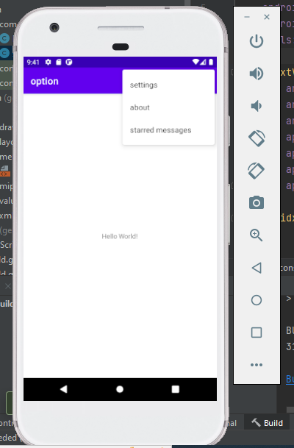

**Result :** The program was executed successfully and the output was obtained.